MATERIAL AND METHODS

Sensitivity, Specificity, Precision, F1 score, and Accuracy Statistical Measures
Sensitivity (also called recall) measures the proportion of actual positives correctly identified, and specificity measures the proportion of negatives correctly identified. These measures are defined in terms of true positives (TP), false positives (FP), true negatives (TN), and false negatives (FN) as follow:
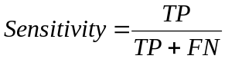
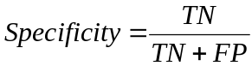
A sensitivity of 1 would mean that the model recognizes all critical residues as such; while a specificity of 1.0 means that the model recognizes non-critical residues as such.
The precision rates is the fraction of predicted critical residues that are indeed critical residues, and is calculated as follow:
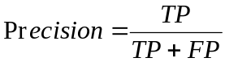
The F1 score measures the balance precision (P) and sensitivity or recall (R) rates and is calculated as follow:
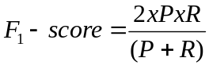
Finally, accuracy measures the closeness of the prediction to the experimental data and is defined using following formula:
The accuracy values were calculated at a specific probability threshold at which false positives and false negatives have an equal cost probability. In order to derive this probability threshold, we identified the point on the ROC curve where the gradient equals one and is closest to the point (0, 1).

Gly-Ala mutagenesis analysis of VH-AntiRAS-HRAS complex
The plasmids
The triplex vector was used for “one plasmid” mammalian two-hybrid assays (M2H). The detail construction of the plasmid will be described elsewhere (TT and THR, manuscript in press). Anti-RAS VH single domain cDNA sequences were cloned in-frame with the VP16 transactivation domain controlled by human EF1a promoter to encode a VH-VP16 fusion protein and the HRASG12V (or control antigen) was cloned in-frame with the Gal4DBD (controlled by the SV40 promoter) to encode a GAL4DBD-HRASG12V fusion protein. All constructs were sequenced to confirm in-frame fusion of the inserts with fusion partners.

Site-directed mutagenesis for glycine/alanine scanning
Mutagenesis of the CDR residues of the anti-RAS VH#6 were performed essentially as described in Tanaka et al.(1) using pEFVP16-VH#6(2) as the parental template for the PCR reactions. Each mutagenesis comprised synthesis of two overlapping PCR products using mutant oligonucleotides (step one PCR), followed by complete fragment assembly (step two PCR) and cloning upstream of the VP16 activator domain of the triplex vector.
Step one PCR reactions contained 10 ng pEFVP16-VH#6 template and 0.5 uM of each reverse mutagenesis oligonucleotide plus 0.5 uM of the EFFP2 primer (5’- GGAGGGGTTTTATGCGATGG -3’) (a forward primer binding within the the EF-1a promoter) or 0.5 uM of the forward mutagenesis oligonucleotide plus 0.5 uM of the VP162R primer (5’- CAACATGTCCAGATCGAA -3’) (a back primer binding within the VP16 activation sequence) with 1 unit of KOD DNA polymerase (TOYOBO) in 2 mM MgCl₂, 0.2 mM dNTPs, 1 x KOD PCR buffer and 10 ng pEFVP16-VH#6 template. PCR reactions were carried out after denaturation at 95 ˚C for 2 min, followed by 40 cycles of 95 ˚C for 20 sec, 61 ˚C for 10 sec and 70 ˚C for 20 sec with final extension at 70 ˚C for 5 min. The PCR products were electrophoresed on 2% agarose gels, extracted and purified using QIAquick Gel Extractions (Qiagen). Purified PCR fragments were used as templates for step two PCR reactions.
Step two PCR reactions used EFFP2 and VP162R as primers and equal amounts of the step one fragments as templates (approximately 1 ng each). Reactions were carried out under the same thermo-cycler conditions as step one PCR. The assembled PCR fragments were purified using QIAquick PCR purification kits (Qiagen), digested with SfiI and NotI, purified by agarose gel electrophoresis and cloned into the SfiI and Notl sites of the Triplex vector. The final constructs were verified by DNA sequencing.
Tables

Table 1. Dataset of protein complexes used in this study. ª Antigen-Antibody or non-evolutionary related complexes; ^{b} Kortemme and Baker, 2002(3); ^{c} ASEdb database(4); ^{d} Guerois et al. 2002(5); ^{e} BID database(6); * in Kcal.mol⁻¹

PDB code | Partner Protein | Mutated Protein | Source | No.  interface residues | No. critical residues  (ΔG≥2.0)*
1a22 | Extracellular domain of human growth hormone receptor (chain B) | G120R mutant of human growth hormone (chain A) | b | 38 | 3
1a22 | G120R mutant of human growth hormone (chain A) | Receptor extracellular domain of human growth hormone (chain B) | b | 38 | 4
1a4y | Human Angiogenin (chain B) | Human placental RNase inhibitor (chain A) | b | 45 | 2
1a4y | Human placental RNase inhibitor (chain A) | Human Angiogenin (chain B) | b | 45 | 1
1ahwª | Anti-human-TF Fab, 5G9 (chains A,B) | Extra-cellular modules of human Tissue Factor (chain C) | b | 29 | 1
1brs | Intracellular polypeptide inhibitor, barstar (chain D) | Bacterial ribonuclease, barnase (chain A) | b | 23 | 6
1brs | Bacterial ribonuclease, barnase (chain A) | Intracellular polypeptide inhibitor, barnstar (chain D) | b | 23 | 3
1bxiª | E. coli colicin E9 DNase (chain B) | Immunity protein Im9 (chain A) | b | 23 | 7
1cbw | Bovine Chymotrypsin (chain A,B,C) | Basic pancreatic trypsin inhibitor BPTI (chain D) | b | 15 | 1
1dan | Coagulation factor VIIa (chains L,H) | Human Tissue Factor (chain T) | b | 52 | 2
1dan | Coagulation factor VIIa (chains L,H) | Human Tissue Factor (chain U) | b | 52 | -
1dan | Human Tissue Factor (chains U,T) | Coagulation factor VIIa (chain L) | b | 52 | -
1dfj | RNase A (chain E) | RNase inhibitor (chain I) | b | 51 | 4
1dn2ª | Fc fragment of human IgG1 (chain A) | 13-amino acids peptide (chain E) | b | 12 | 2
1dvfª | Anti-hen-egg-white lysozyme antibody D1.3 (chains A,B) | Anti-idiotopic antibody E5.2 (chain D) | c | 31 | 2
1dvfª | Anti-idiotopic antibody E5.2 (chain D) | Ab D1.3 (chain A) | c | 5 | -
1dvfª | Anti-idiotopic antibody E5.2 (chain D) | Ab D1.3 (chain B) | c | 16 | 4
1f47 | Membrane-anchored protein ZipA (chain B) | A homologue of eukaryotic tubulin FtsZ fragment (chain A) | b | 12 | 3
1fc2ª | Human Fc (chain D) | Staphylococcus aureus Protein A (chain C) | b | 16 | 1
1fccª | Fc of human IgG (chain A) | Streptococcal Protein G (chain C) | b | 19 | 4
1iar | IL-4 receptor alpha chain Receptor alpha (chain B) | Interleukin-4 (chain A) | d | 20 | 1
1jckª | T-cell receptor beta chain (chain A) | Sec3 superantigen (chain B) | c | 22 | 4
1jrhª | Interferon-gamma receptor alpha chain (chain I) | Neutralizing antibody A6 (chain L) | b | 9 | 1
1jrhª | Interferon-gamma receptor alpha chain (chain I) | Neutralizing antibody A6 (chain H) | b | 11 | -
1jrhª | Neutralizing antibody A6 (chains L, H) | Interferon-gamma receptor alpha chain (chain I) | b | 20 | 5
1jtd | Beta-lactamase inhibitor protein (chain B) | Tem-1 beta-lactamase (chain A) | d | 28 | -
1vfbª | Hen egg white lysozyme (chain C) | Anti-hen-egg-white lysozyme antibody D1.3 (chains A, B) | c | 22 | 2
1vfbª | Anti-hen-egg-white lysozyme antibody D1.3 (chains A, B) | Hen egg white lysozyme (chain C) | c | 22 | 1
2ptc | Bovine trypsin (chain E) | Basic pancreatic trypsin inhibitor BPTI (chain I) | b | 15 | 1
3hfmª | Anti-lysozyme Fab (chains L, H) | Hen egg white lysozyme (chain Y) | b | 25 | 4
3hfmª | Hen egg white lysozyme (chain Y) | Anti-lysozyme Fab (chain H) | b | 14 | 1
1dx5 | Thrombomodulin (chain I) | Thrombin heavy chain (chain M) | e | 17 | 4
1gc1 | Envelope protein GP120 (chain G) | CD4 (chain C) | e | 24 | -
1jtg | Beta-lactamase (chain A) | Beta-lactame inhibitor (chain B) | e | 37 | 3
1ktz | TGF-beta 3 (chain A) | TGF-beta-II Receptor (chain B) | e | 15 | 2
1nmbª | N9 Neuraminidase (chain N) | Fab NC10 (chain H) | e | 11 | -

Table 2. Average number of contacts by residue type when in protein-protein interfaces. ª AV: average; ^{b} STD: Standard deviation.

Aa type | AVª | STD^{b}
ASP | 2.568 | 1.602
PRO | 2.785 | 1.735
ILE | 3.261 | 2.023
LYS | 2.746 | 1.891
CYS | 2.634 | 1.612
TRP | 3.987 | 2.726
GLY | 2.259 | 1.379
PHE | 3.819 | 2.429
GLN | 3.062 | 1.876
SER | 2.489 | 1.572
ASN | 3.001 | 1.867
VAL | 2.937 | 1.864
LEU | 3.215 | 2.088
GLU | 2.749 | 1.748
TYR | 3.731 | 2.306
ARG | 3.542 | 2.312
THR | 2.788 | 1.716
MET | 3.522 | 2.298
ALA | 2.432 | 1.481
HIS | 3.212 | 1.999

Table 3. AUC values for different naïve BNs architectures tested during the training phase. IE: interaction engagement index (as described in Material and Method); TOP: topographical index; BE: predicted binding energy; CON: sequence conservation index; 3DCON: 3D regional conservation index; ANCCON: anchor sequence conservation index; ANC3DCON: anchor 3D regional conservation index.

Measures | AUC |  | Measures | AUC
 | Ab+ | Ab- |  | Ab+ | Ab-
IE | 0.7607 | 0.7439 | TOP BE 3DCON | 0.8331 | 0.9128
TOP | 0.7583 | 0.7497 | TOP BE ANCCON | 0.8376 | 0.8782
BE | 0.7396 | 0.8003 | TOP BE ANC3DCON | 0.8461 | 0.8874
CON | 0.6149 | 0.7424 | TOP CON ANCCON | 0.7836 | 0.8487
3DCON | 0.5960 | 0.7332 | BE CON ANC3DCON | 0.7559 | 0.8864
ANCCON | 0.5394 | 0.5728 | BE CON 3DCON | 0.7225 | 0.8558
ANC3DCON | 0.6310 | 0.6990 | TOP BE CON 3DCON | 0.8211 | 0.9018
IE TOP | 0.7747 | 0.7560 | TOP BE CON ANCCON | 0.8342 | 0.9102
IE BE | 0.8288 | 0.8454 | TOP BE CON ANC3DCON | 0.8442 | 0.9162
IE CON | 0.7669 | 0.8057 | TOP BE ANCCON ANC3DCON | 0.8468 | 0.8927
IE 3DCON | 0.7728 | 0.8337 | TOP BE 3DCON ANC3DCON | 0.8436 | 0.9298
IE ANCCON | 0.7645 | 0.7619 | BE CON 3DCON ANC3DCON | 0.7385 | 0.8775
IE ANC3DCON | 0.7828 | 0.8003 | CON 3DCON ANCCON ANC3DCON | 0.6458 | 0.8056
TOP BE | 0.8387 | 0.8662 | IE TOP BE CON | 0.8393 | 0.8857
TOP CON | 0.7690 | 0.8276 | IE TOP BE 3DCON | 0.8368 | 0.8942
TOP 3DCON | 0.7802 | 0.8601 | TOP BE CON 3DCON ANC3DCON | 0.8278 | 0.9157
TOP ANCCON | 0.7647 | 0.7706 | IE BE CON 3DCON ANCCON | 0.8070 | 0.8876
TOP ANC3DCON | 0.7750 | 0.7970 | IE BE CON 3DCON ANC3DCON | 0.8220 | 0.8958
BE CON | 0.7457 | 0.8592 | IE TOP BE CON 3DCON | 0.8360 | 0.9015
BE 3DCON | 0.7296 | 0.8647 | IE TOP BE CON ANCCON | 0.8399 | 0.8943
BE ANCCON | 0.7442 | 0.8120 | IE TOP BE CON ANC3DCON | 0.8478 | 0.8967
BE ANC3DCON | 0.7633 | 0.8548 | IE TOP BE 3DCON ANCCON | 0.8367 | 0.8988
CON 3DCON | 0.6051 | 0.7674 | IE TOP BE 3DCON ANC3DCON | 0.8460 | 0.9078
CON ANCCON | 0.6324 | 0.7632 | IE TOP BE ANCCON ANC3DCON | 0.8410 | 0.8770
CON ANC3DCON | 0.6549 | 0.7869 | IE TOP BE CON 3DCON ANCCON | 0.8350 | 0.9083
IE TOP BE | 0.8320 | 0.8432 | IE TOP BE CON 3DCON ANC3DCON | 0.8427 | 0.9147
IE BE CON | 0.8261 | 0.8842 | TOP BE CON 3DCON ANCCON ANC3DCON | 0.8261 | 0.9201
IE TOP CON | 0.7869 | 0.8123 | IE BE CON 3DCON ANCCON ANC3DCON | 0.8217 | 0.9012
IE TOP 3DCON | 0.7903 | 0.8482 | IE TOP CON 3DCON ANCCON ANC3DCON | 0.8053 | 0.8743
TOP BE CON | 0.8355 | 0.9040 | IE TOP BE CON 3DCON ANCCON ANC3DCON | 0.8434 | 0.9173

Table 4. AUC values for different expert BNs tested during the training phase. IE: interaction engagement index (as described in Material and Method); TOP: topographical index; BE: predicted binding energy; CON: sequence conservation index; 3DCON: 3D regional conservation index; ANCCON: anchor sequence conservation index; ANC3DCON: anchor 3D regional conservation index.

Measures | AUC
 | Ab+ | Ab-
IE TOP | 0.7734 | 0.7685
TOP BE | 0.8365 | 0.8698
TOP ANCCON | 0.7475 | 0.7710
TOP ANC3DCON | 0.7703 | 0.8161
CON ANC3DCON | 0.6506 | 0.7847
IE TOP BE | 0.8431 | 0.8872
TOP BE CON | 0.8302 | 0.8988
TOP BE 3DCON | 0.8319 | 0.9153
TOP CON ANC3DCON | 0.7813 | 0.8485
BE CON ANCCON | 0.7452 | 0.8592
BE CON ANC3DCON | 0.7553 | 0.8978
IE TOP BE CON | 0.8445 | 0.9059
IE TOP BE 3DCON | 0.8512 | 0.9198
TOP BE CON 3DCON | 0.8460 | 0.9143
TOP BE CON ANCCON | 0.8412 | 0.9183
TOP BE CON ANC3DCON | 0.8492 | 0.9257
TOP BE 3DCON ANC3DCON | 0.8517 | 0.9366
CON 3DCON ANCCON ANC3DCON | 0.6803 | 0.8078
TOP BE CON 3DCON ANC3DCON | 0.8558 | 0.9354
IE TOP BE CON 3DCON | 0.8590 | 0.9175
IE TOP BE 3DCON ANC3DCON | 0.8613 | 0.9403
IE TOP BE CON 3DCON ANC3DCON | 0.8535 | 0.9383
TOP BE CON 3DCON ANCCON ANC3DCON | 0.8656 | 0.9441
IE BE CON 3DCON ANCCON ANC3DCON | 0.8609 | 0.9275
IE TOP BE CON 3DCON ANCCON ANC3DCON | 0.8799 | 0.9447

Figures

Figure 1. Percentage of recovered critical residues (ddG≥2.0 Kcal.mol⁻¹) (Y-axis) as a function of screened interface residues (X-axis). Predictions were performed under a leave-one-out cross validation experiment, i.e. one of the protein complex was selected as test set while the rest of protein complexes were used as training set. The percentage of recovery was calculated as the fraction of critical residues with a probability equal or larger than 0.8 divided by the total number of experimentally validated critical residues. Empty circles and cross represent prediction performed by a naïve and expert BN respectively.

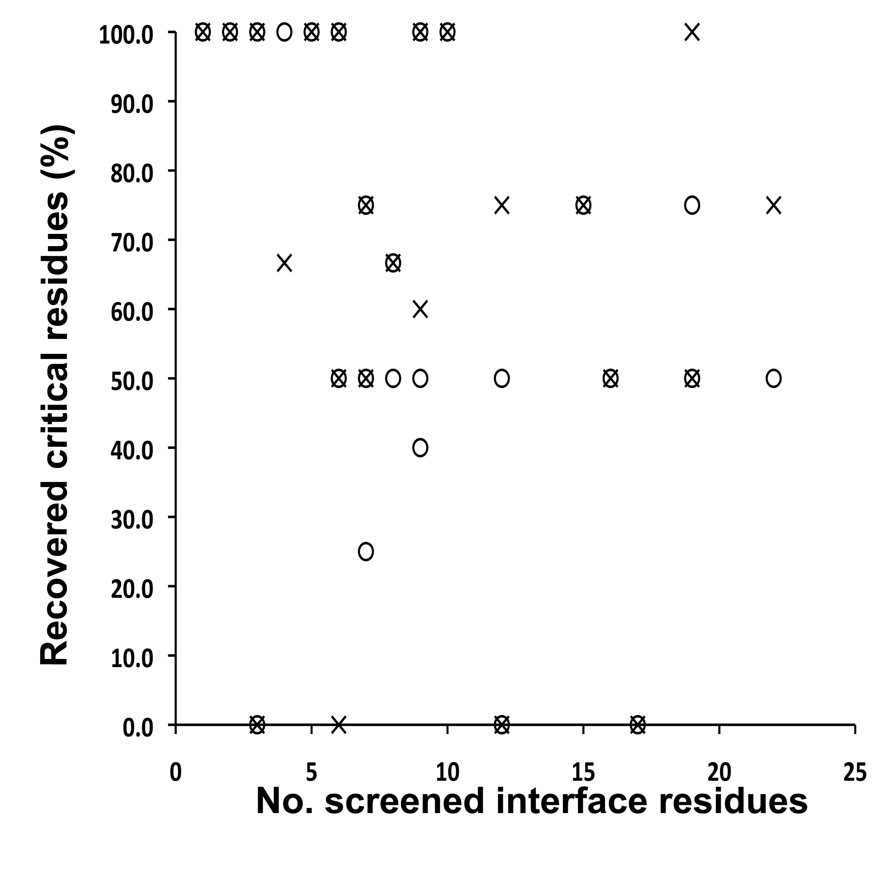

References

1. Tanaka, T. and Rabbitts, T.H. (2003) Intrabodies based on intracellular capture frameworks that bind the RAS protein with high affinity and impair oncogenic transformation. Embo J, 22, 1025-1035.
2. Tanaka, T., Lobato, M.N. and Rabbitts, T.H. (2003) Single domain intracellular antibodies: a minimal fragment for direct in vivo selection of antigen-specific intrabodies. J Mol Biol, 331, 1109-1120.
3. Kortemme, T. and Baker, D. (2002) A simple physical model for binding energy hot spots in protein-protein complexes. Proc Natl Acad Sci U S A, 99, 14116-14121.
4. Thorn, K.S. and Bogan, A.A. (2001) ASEdb: a database of alanine mutations and their effects on the free energy of binding in protein interactions. Bioinformatics, 17, 284-285.
5. Guerois, R., Nielsen, J.E. and Serrano, L. (2002) Predicting changes in the stability of proteins and protein complexes: a study of more than 1000 mutations. J Mol Biol, 320, 369-387.
6. Fischer, T.B., Arunachalam, K.V., Bailey, D., Mangual, V., Bakhru, S., Russo, R., Huang, D., Paczkowski, M., Lalchandani, V., Ramachandra, C. et al. (2003) The binding interface database (BID): a compilation of amino acid hot spots in protein interfaces. Bioinformatics, 19, 1453-1454.

